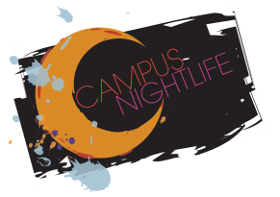
Campus NightLife
Street Team Intent Form
Campus NightLife (CNL) is looking for motivated students who are interested in joining our Street Team. The Street Team is responsible for creating and implementing a marketing plan for each event that includes, but not limited to: chalking the Union Plaza, working Nebraska Union Booths, making house announcements at Greek Chapter meetings, posting flyers on campus/near campus locations, and volunteering at Campus NightLife Events. Street Team works closely with CNL members and committee members that are advised by Reshell Ray, Ly Nguyen and Brian Donahue.
Students' interested in applying should:
1. Be passionate student volunteers that help spread the word about upcoming CNL events
2. Ensure that CNL events are properly marketed to the students on campus
3. Maintain consistent communication with the Street Team Leader, Ly Nguyen about important information regarding events
4. Develop innovative and creative ideas to reach the student market at the university
5. Be willing to work as a team to promote and advertise events
6. Work 1-3 hours handling/promoting/ working on publicity prior to all events
7. Be able and willing to communicate and advertise events to all demographics of students

If interested in applying, please fill out the Street Team intent form and return it to the Student Involvement Office located in Nebraska Union Room 200 by September 29, 2014.

First Name:_________________________________ Last Name:______________________________
NUID:____________________________________ Email:__________________________________
Phone Number:________________________________

Please provide a short answer to the questions below.
1. Explain two personal strengths that you could bring to Street Team.

